Experiment-1A: Date: 10-07-2026
****
Aim: Write a HTML program, to explain the working of lists.
Source Code:
<!DOCTYPE html>
<html>
<head>
<title>HTML Lists</title>
</head>
<body>
<h2>Roll No: 249XA33001, Name: ABID</h2>
<h2>----- OUTPUT -----</h2>
<h2>Different Types of Lists in HTML</h2>

<h2>1. Ordered List</h2>
<ol>
<li>FSD1</li>
<li>CPP</li>
<li>DS</li>
<li>ML</li>
</ol>

<h2>2. Unordered List</h2>
<ul>
<li>Apple</li>
<li>Banana</li>
<li>Mango</li>
<li>Orange</li>
</ul>

<h2>3. Nested List</h2>
<ul>
<li>Engineering
<ul>
<li>CSE</li>
<li>ECE</li>
<li>EEE</li>
</ul>
</li>
<li>Management</li>
</ul>

<h2>4. Ordered List inside an Unordered List</h2>
<ul>
<li>Programming Languages
<ol>
<li>Python</li>
<li>Java</li>
<li>C++</li>
</ol>
</li>
</ul>

<h2>5. Definition List</h2>
<dl>
<dt><b>HTML</b></dt>
<dd>HyperText Markup Language.</dd>

<dt><b>CSS</b></dt>
<dd>Cascading Style Sheets.</dd>

<dt><b>JavaScript</b></dt>
<dd>Programming language used for web development.</dd>
</dl>
<h2>----- END of the OUTPUT -----</h2>
<h2>Roll No: 249XA33001, Name: ABID</h2>
</body>
</html>
Snapshot of the Output Webpage:
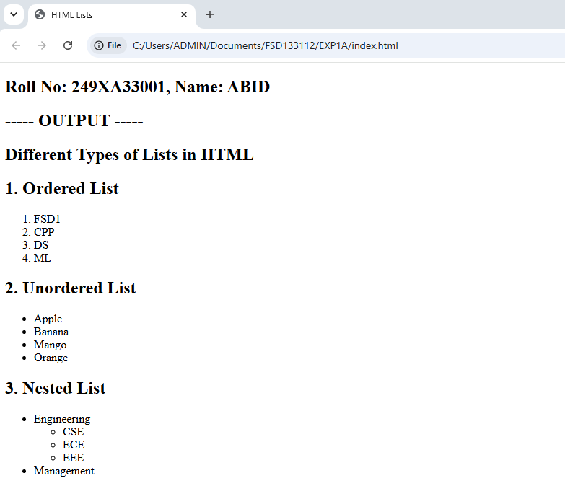
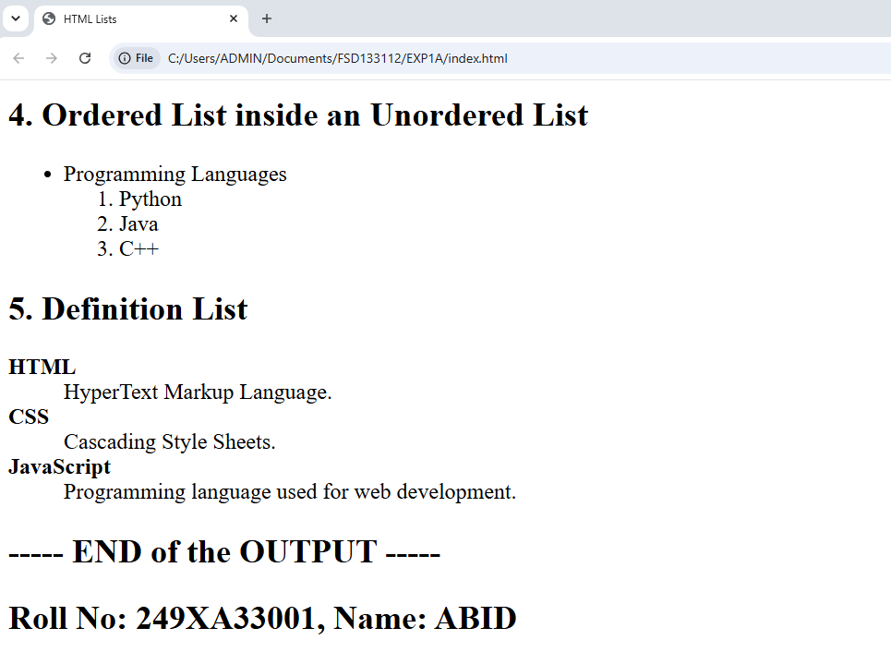

Signature of the Faculty

:

Experiment-1B: Date: 10-07-2026
****
Aim: Write a HTML program to explain the working of hyperlinks using <a> tag and href, target attributes.
Source Code:
<!DOCTYPE html>
<html>
<head>
<title>Hyperlinks Example</title>
</head>
<body>
<h2>Roll No: 249XA33001, Name: ABID</h2>
<h2>----- OUTPUT -----</h2>
<h2>Working of Hyperlinks</h2>

<p>
Visit Google:
<a href="https://www.google.com">
Google
</a>
</p>

<p>
Open Wikipedia in a New Tab:
<a href="https://www.gprec.ac.in" target="_blank">
GPREC
</a>
</p>

<p>
Visit OpenAI:
<a href="https://www.openai.com" target="_blank">
OpenAI
</a>
</p>
<h2>----- END of the OUTPUT -----</h2>
<h2>Roll No: 249XA33001, Name: ABID</h2>
</body>
</html>

Snapshot of the Output Webpage: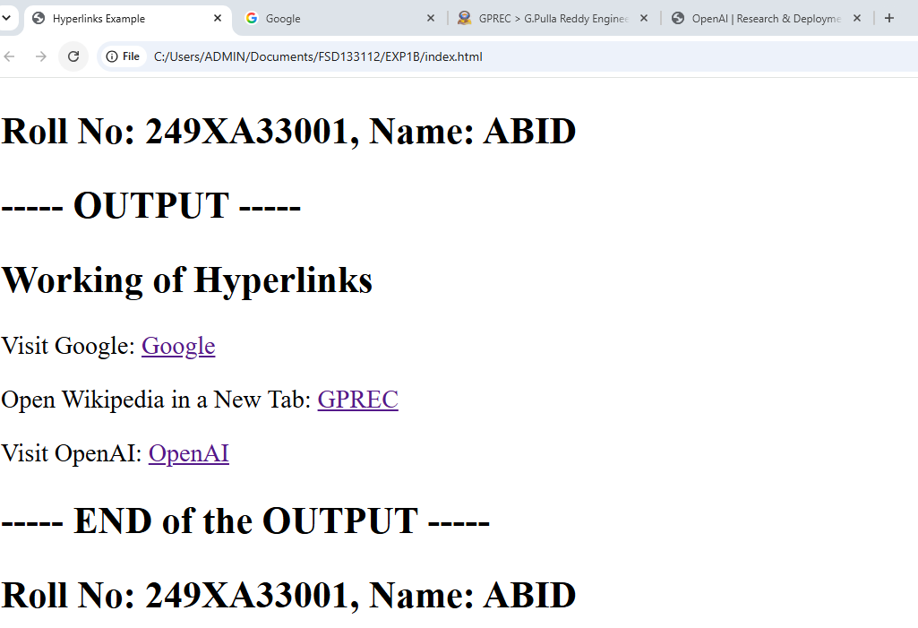

Signature of the Faculty

Experiment-1C: Date: 10-07-2026
****
Aim: Write a HTML program to create a HTML document that has your image and your friend’s image with a specific height and width. Also, when clicked on the images it should navigate to their respective profiles.
Source Code:
<!DOCTYPE html>
<html>
<head>
<title>Images with Links</title>
</head>
<body>
<h2>Roll No: 249XA33001, Name: ABID</h2>
<h2>----- OUTPUT -----</h2>
<h1>Clickable Images</h1>

<h2>My Image</h2>

<a href="https://www.instagram.com" target="_blank">
<img src="abid.jpeg"
alt="My Photo"
width="250"
height="250">
</a>

<br><br>

<h2>Friend's Image</h2>

<a href="https://in.linkedin.com" target="_blank" >
<img src="anil.jpeg"
alt="Friend Photo"
width="250"
height="250">
</a>
<h2>----- END of the OUTPUT -----</h2>
<h2>Roll No: 249XA33001, Name: ABID</h2>
</body>
</html>

Snapshot of the Output Webpage: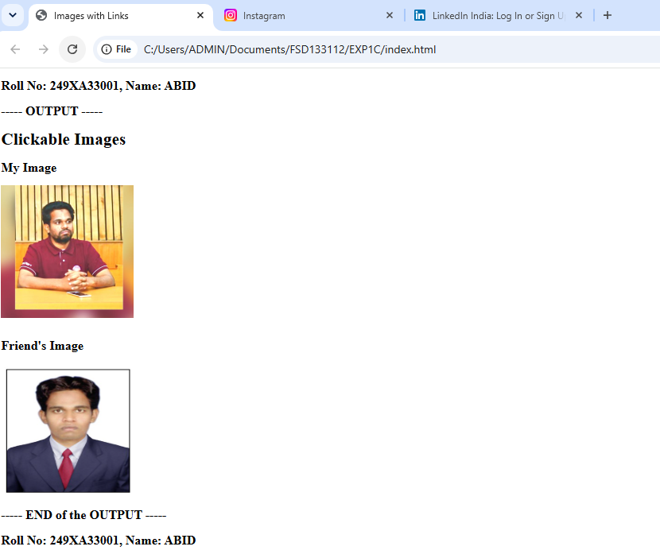

Signature of the Faculty

Experiment-1D: Date: 10-07-2026
****
Aim: Write a HTML program to create a HTML document that has your image and your friend’s image with a specific height
Source Code:
<!DOCTYPE html>
<html>
<head>
<title>Thumbnail Image Gallery</title>
</head>
<body>
<h2>Roll No: 249XA33001, Name: ABID</h2>
<h2>----- OUTPUT -----</h2>
<h1>Image Gallery</h1>

<p>Click any thumbnail to view the full-size image.</p>

<a href="abid.jpeg" target="_blank">
<img src="abid.jpeg"
width="100"
height="100"
alt="Image 1">
</a>

<a href="hari.jpeg" target="_blank">
<img src="hari.jpeg"
width="100"
height="100"
alt="Image 2">
</a>

<a href="anil.jpeg" target="_blank">
<img src="anil.jpeg"
width="100"
height="100"
alt="Image 3">
</a>

<a href="ravi.jpeg" target="_blank">
<img src="ravi.jpeg"
width="100"
height="100"
alt="Image 4">
</a>
<h2>----- END of the OUTPUT -----</h2>
<h2>Roll No: 249XA33001, Name: ABID</h2>
</body>
</html>
Snapshot of the Output Webpage: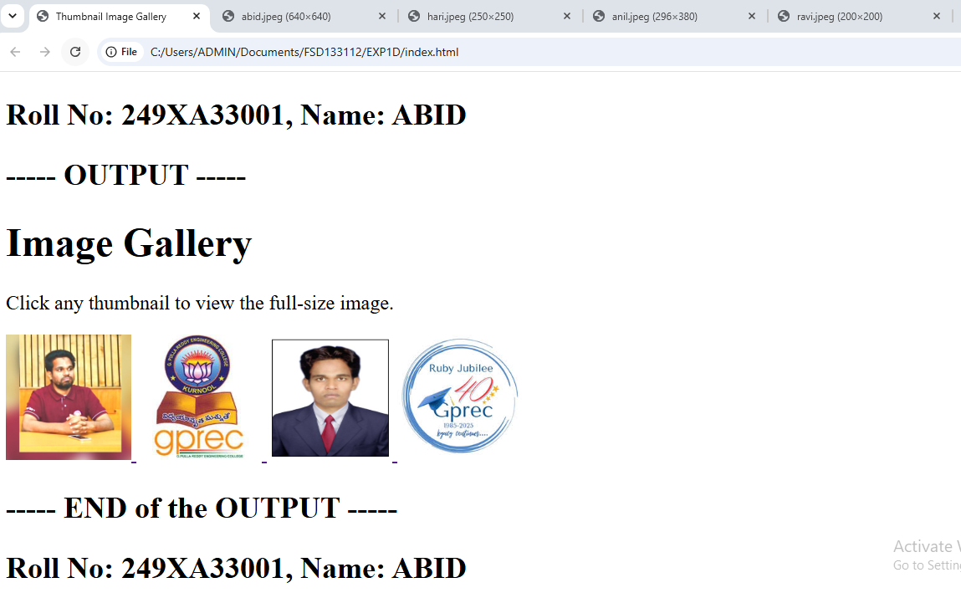

Signature of the Faculty

